

TCG PROJECT REPORT

By [Taszid Chowdhury](mailto:chowdh30@go.stockton.edu)

Introduction

A thorough Java-based program called Pokemon Card Game modeling was created to enable in-depth analysis and modeling of gameplay situations in the Pokemon trading card game (TCG). In order to help players make wise decisions and maximize their gameplay tactics, the program seeks to give them insightful knowledge about the statistical possibilities and dynamics of different game scenarios.

Purpose

The goal of this project is to develop a playable Pokémon card game simulation that showcases important object-oriented design and programming ideas. Through a variety of card types, game mechanisms, and player interactions, the project seeks to offer an engaging and instructive experience that highlights inheritance, encapsulation, and polymorphism.

Features

Menu

When the program begins you are shown the menu screen.

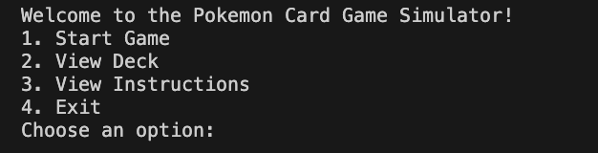

In this menu screen you are given you can start the game view the deck view the instructions and also exit the program. The view deck shows a list of all the cards that you will be able to use in the program. The view instruction gives a simple instruction for new players.

Start Game

The first option in the menu is Start Game. Entering 1 in the output will make it so the programs main features begins.

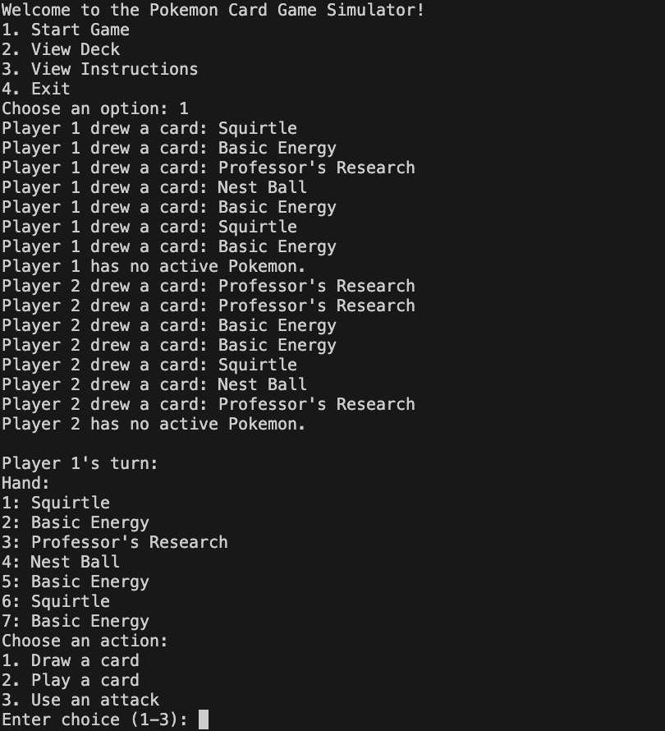

Once the program starts you are shown player 1 and player 2 deck. Each player starts of with 7 cards in their hand from a deck of 60 cards. Each player is given the choice to draw a card to their hand, play a card that is currently in their hand and use an attack using a pokemon card.

Drawing a card

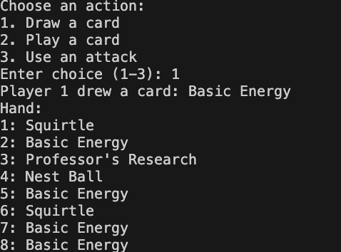

Play a card

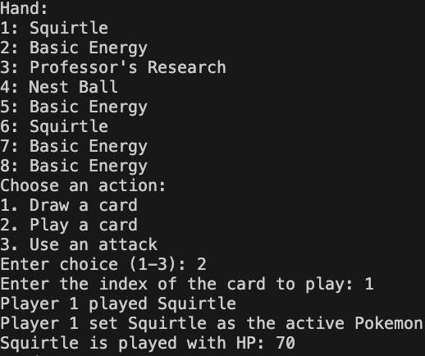

In this instance the player played a squirtle which a pokemon card. When a pokemon card is activated it shows its hp

Use an attack

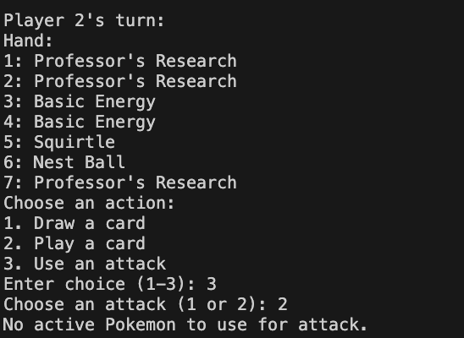

When attacking certain variables have to be met. One of the variable is that you need to have a pokemon activated. To activate a pokemon you need to play a pokemon card.

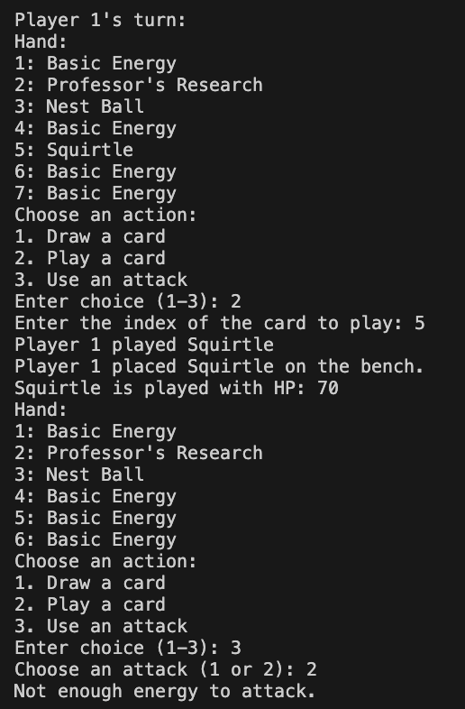

On top of playing the pokemon card you need to also play an energy card so the pokemon is able to attack.

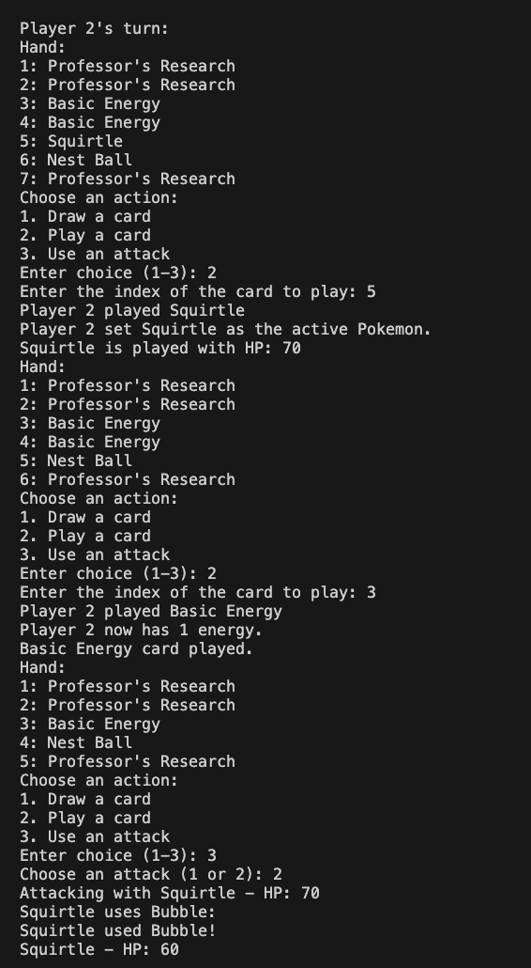

Successful attack

Available Pokemon

The three available pokemon in my program are Charmander, Squirtle, and Bulbasaur. Each having two specific attacks and their respective hp.

Charmander

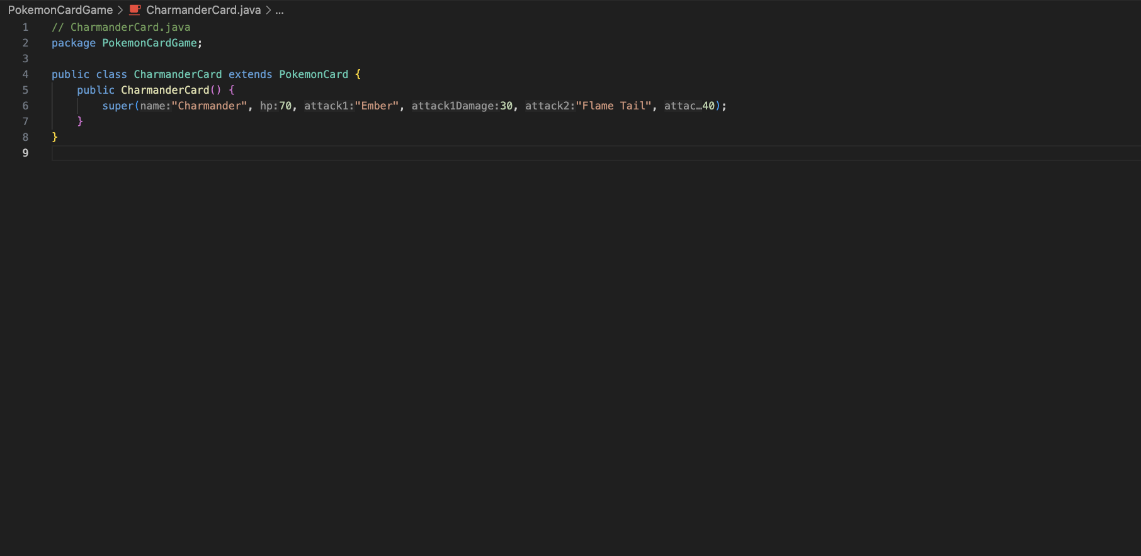

Squirtle

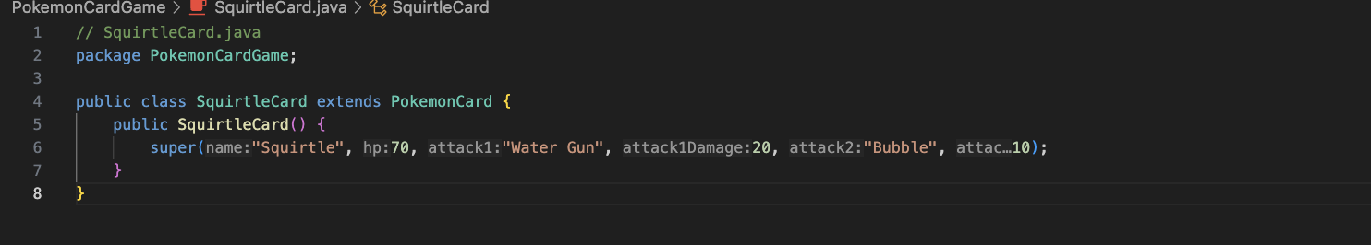

Bulbasaur

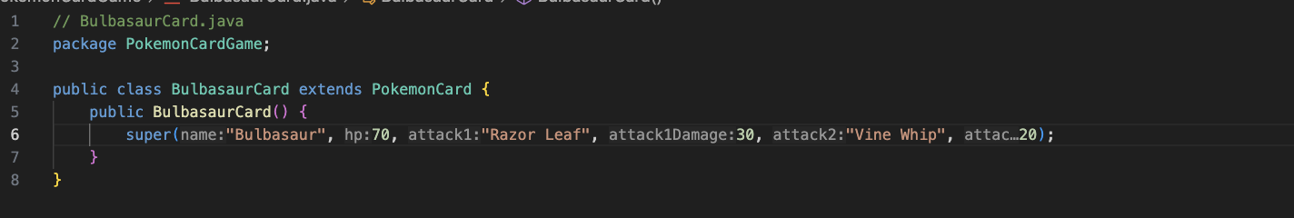

Each pokemon has two different attacks with each varying level of attack powers.

Trainer Cards  
Two Specific trainer cards that I have implemented are the professor research card which discards your current hand and makes you pick out 7 new cards and the nest ball which searches your deck for a Basic Pokémon and put it onto your Bench. Then, shuffle your deckSearch your deck for a Basic Pokémon and put it onto your Bench. Then, shuffle your deck

Nest Ball Code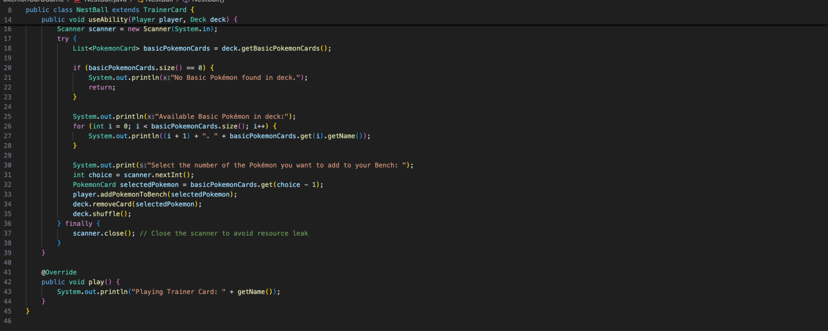

Professors Research Code

